EIE3312 Linear System

Fourier Series

Experiment Report

Name: YANG Tianyu

Student ID: 13102841D

Date: 2015/3/30

**Introduction:**

In order to represent a wave-like function, we use a Fourier series to simplify it as the sum of harmonically-related sinusoids with specific frequency. In other words, it can decompose any periodic function or periodic signal into the sum of simple oscillating function, such as sine function or cosine function. Continuous-time Fourier Transform (CTFT) can describe non-periodic signals in term of frequency content. Moreover, complex exponential are used in the representation instead of the sinusoids. Fourier transform is to be used when dealing with the non-periodic continuous-time signals. This is also an extension of the Fourier series by increasing the periods to infinity.

The period T of a continuous-time signal is said to satisfy the equation below. 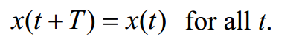

The fundamental period T0 of x(t) is the smallest positive value of T, which need to be satisfied the equation below. The fundamental frequency is 1/ T0 = f0.

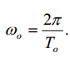

The complex exponential Fourier series of the signal is the equation below.

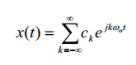

**Procedure:**

Synthesizing Continuous-Time Signals with the Fourier Series

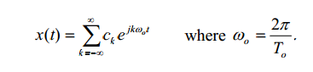The Fourier Series synthesis equation for a continuous-time signal x(t) with fundamental period T0 is given in the equation.

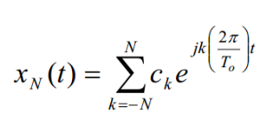The Fourier series coefficients can have an infinite number of nonzero values. However, the finite sum is often a very good approximation for some relatively small integer N. The equation is often called the truncated Fourier series representation of x(t).

1. For each of the following signals, create an expression for the continuous-time signal, and plot the signal over two periods using ezplot or plot.

To find the expression of the continuous-time signal, we simplify the equation into this one.

X(t) = (-1/2)/(j*k*π)*($e^{-\left(\frac{1}{2}\right)*j*k*π}$- $e^{\begin{aligned}- \\ \left(\frac{1}{2}\right)*j*k*π\end{aligned}}$)

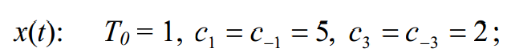

(i)

Code in the Matlab:

t1=[-1:0.01:1];

x1=5.*exp(j*t1*2*pi)+5.*exp(-j*t1*2*pi)+2.*exp(3*j*t1*2*pi)+2.*exp((-3)*j*t1*2*pi);

plot(t1,x1)

(ii)

Code in the Matlab:

t2=[-2:0.01:2];

x2=j*exp(j*t2*pi)-j*exp(-j*t2*pi)+(-0.5)*j*exp(2*j*t2*pi)+0.5*j*exp((-2)*j*t2*pi)+0.25*j*exp(3*j*t2*pi)-0.25*j*exp((-3)*j*t2*pi)+(-0.125)*j*exp(4*j*t2*pi)+0.125*j*exp((-4)*j*t2*pi);

plot(t2,x2)



(iii)

Code in the Matlab:

t3=[-3:0.01:3];

x3=j*exp(j*t3*2*pi/3)-j*exp(-j*t3*2*pi/3)+0.5*j*exp(2*j*t3*2*pi/3)-0.5*j*exp((-2)*j*t3*2*pi/3)+0.25*j*exp(3*j*t3*2*pi/3)-0.25*j*exp((-3)*j*t3*2*pi/3)+0.125*j*exp(4*j*t3*2*pi/3)-0.125*j*exp((-4)*j*t3*2*pi/3);

plot(t3,x3)

(b) In this part you will analyze a periodic square wave with the Fourier series. You will see

how xN(t) converges as N increases.

Consider a periodic square wave, x(t), with fundamental period T0 = 2 over the interval –

−1≤ t ≤1, the square wave is described by

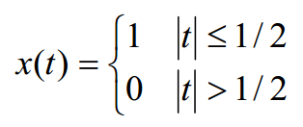

(i) Analytically calculate the Fourier series coefficients of the square wave for each value of k. Use stem to plot the Fourier series coefficients for −10 ≤ k ≤10. (Note the case for k = 0).

Code in the Matlab:

k=[-10:-1,1:10];

x=(-0.5)./(j*k*pi).*(exp((-0.5).*j*k*pi)-exp(0.5.*j*k*pi));

stem(k,x)

hold on

stem(0,0.5)

k=[-10:-1,1:10];

x=(-0.5)./(j*k*pi).*(exp((-0.5).*j*k*pi)-exp(0.5.*j*k*pi));

stem(k,angle(x))

hold on

stem(0,0)

(iii) Write a MATLAB program to compute xN(t) for N = 1, 3, 5, and 9, and plot the corresponding xN(t) on the interval −1≤ t ≤1 (you may plot all four signals on the same figure using hold).

Code in the Matlab:

t=[-1:0.01:1];

y1=0;

y2=0;

y3=0;

y4=0;

for k=-1:-1

x1=(-0.5)./(j*k*pi).*(exp((-0.5).*j*k*pi)-exp(0.5.*j*k*pi));

y1=y1+x1*exp(j*k*pi*t);

end

y1=y1+0.5;

for k=1:1

x1=(-0.5)./(j*k*pi).*(exp((-0.5).*j*k*pi)-exp(0.5.*j*k*pi));

y1=y1+x1*exp(j*k*pi*t);

end

plot(t,y1,'r')

hold on

for k=-3:-1

x2=(-0.5)./(j*k*pi).*(exp((-0.5).*j*k*pi)-exp(0.5.*j*k*pi));

y2=y2+x2*exp(j*k*pi*t);

end

y2=y2+0.5;

for k=1:3

x2=(-0.5)./(j*k*pi).*(exp((-0.5).*j*k*pi)-exp(0.5.*j*k*pi));

y2=y2+x2*exp(j*k*pi*t);

end

plot(t,y2,'b')

hold on

for k=-5:-1

x3=(-0.5)./(j*k*pi).*(exp((-0.5).*j*k*pi)-exp(0.5.*j*k*pi));

y3=y3+x3*exp(j*k*pi*t);

end

y3=y3+0.5;

for k=1:5

x3=(-0.5)./(j*k*pi).*(exp((-0.5).*j*k*pi)-exp(0.5.*j*k*pi));

y3=y3+x3*exp(j*k*pi*t);

end

plot(t,y3,'g')

hold on

for k=-9:-1

x4=(-0.5)./(j*k*pi).*(exp((-0.5).*j*k*pi)-exp(0.5.*j*k*pi));

y4=y4+x4*exp(j*k*pi.*t);

end

y4=y4+0.5;

for k=1:9

x4=(-0.5)./(j*k*pi).*(exp((-0.5).*j*k*pi)-exp(0.5.*j*k*pi));

y4=y4+x4*exp(j*k*pi.*t);

end

plot(t,y4,'black')

(iv) Calculate the value of xN(t) at t = ±1/2. Judge whether the value change as N increases?

(v) Calculate the maximum values of xN(t) with different values of N?

**Result:**

2. (a)

(i) The output figure:

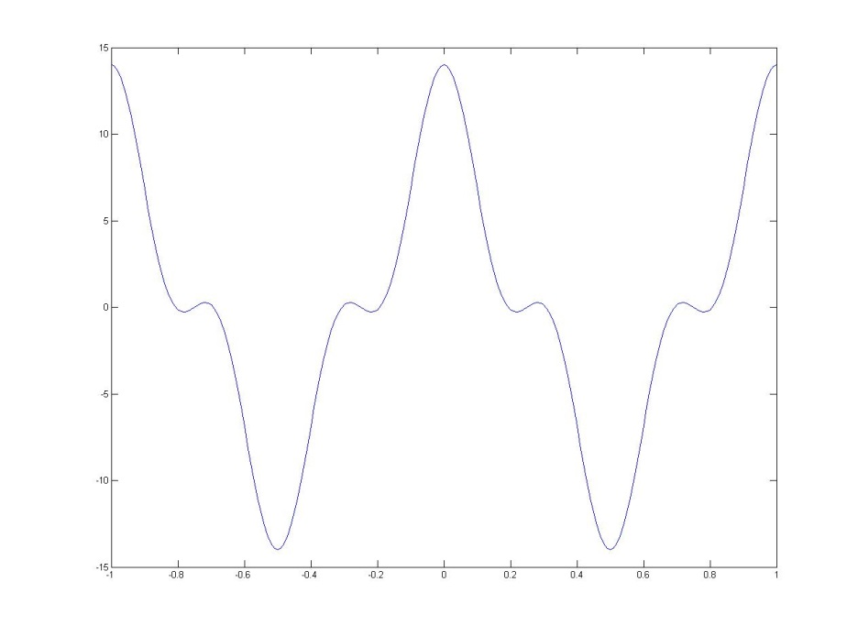

(ii) The output figure:

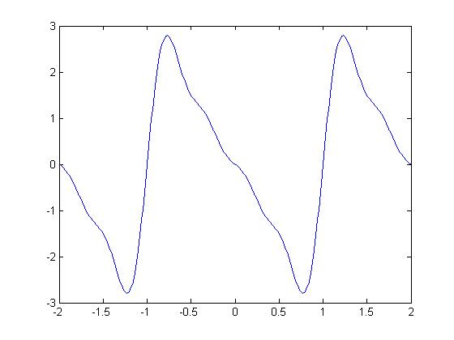

(iii) The output figure:

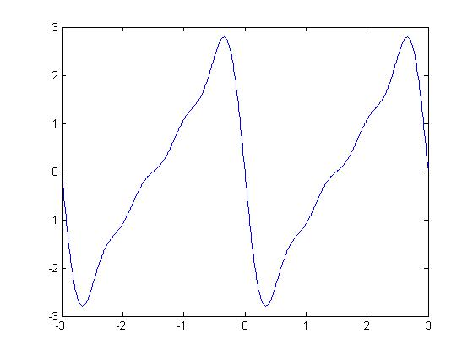

(b)

(i) The output figure:

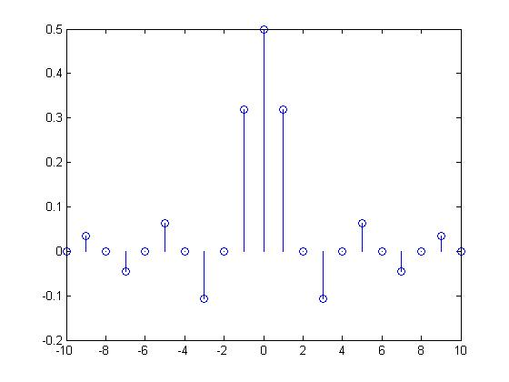

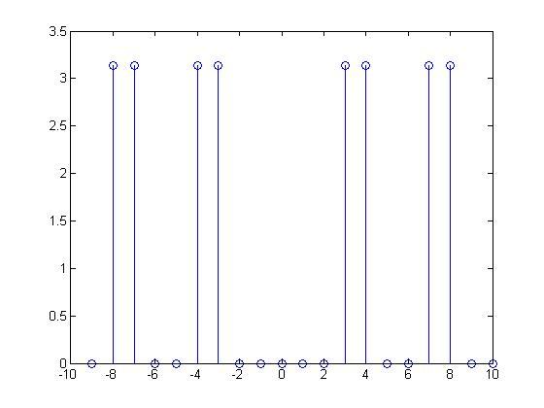

(iii) The output figure:

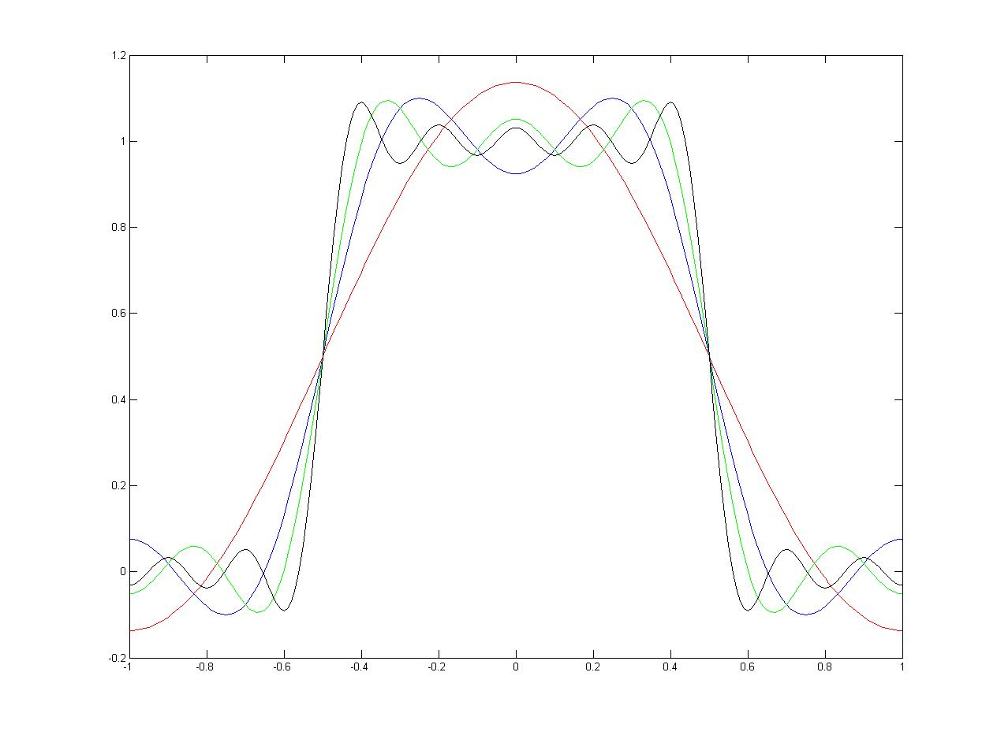

(iv)

xN(t) = 0.5 when t = ±1/2.

The value does not change as N increases.

(v)

As it is showed on the figure below, the maximum values of xN(t) with different values of N is 1.137.

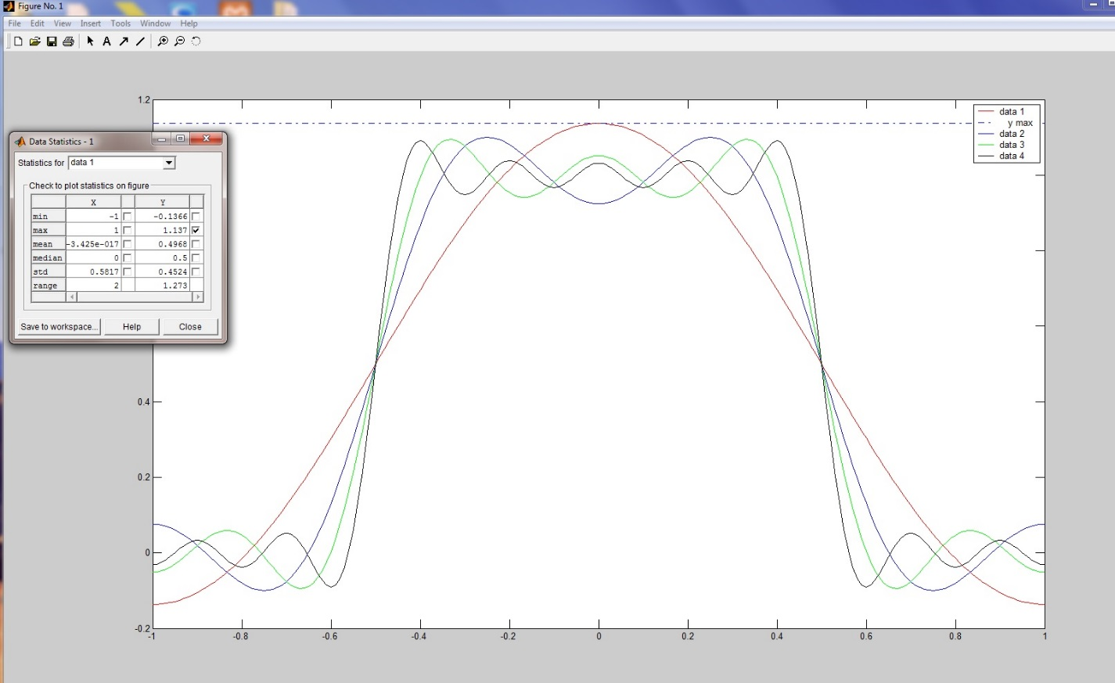

**Conclusion**

This experiment is to help students study the way to use Matlab to solve the problems about Fourier Serier. Firstly, students learn how to use Matlab and using the function of Matlab such as stem, plot, hold on…… Secondly, students learn the method to simplify the Fourier Serier equation and explore analyzing and synthesizing periodic signals with complex exponentials. Thirdly, we gain the figure for the continuous-time signal of different frequency. This can help us compare and analyze the figure when the frequency changed. Finally, this experiment gives us a new visual angle to understand the Fourier Serier. Students can learn a lot in the experiment.